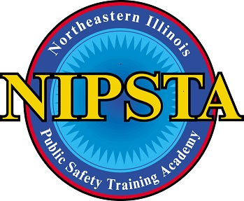
REASONABLE ACCOMODATION REQUEST FORM - CONFIDENTIAL
This form is for use by individuals who wish to request reasonable accommodations for examinations while enrolled in a training program at the Northeastern Illinois Public Safety Training Academy (“NIPSTA”). All sections of this confidential form must be completed in order to determine eligibility and extent of services.
Completed forms must be returned to: NIPSTA Executive Director, 2300 Patriot Boulevard, Glenview, IL 60026, 847-998-8090
DATE | Click here to enter text.
NAME | Click here to enter text.
ADDRESS | Click here to enter text.
TELEPHONE | Click here to enter text.
EMAIL ADDRESS | Click here to enter text.
EMPLOYER | Click here to enter text.
PROGRAM/COURSE | Click here to enter text.

Identify the physical or mental impairment for which you are requesting an accommodation. | Click here to enter text.
Explain how the impairment(s) listed affects your ability to complete a written examination or skills evaluation. | Click here to enter text.
List the accommodations you are requesting in order to complete a written exam or physical skills evaluation. NOTE: Although you may request a specific accommodation, you are not guaranteed to receive the accommodation of your choice. | Click here to enter text.

MEDICAL VERIFICATION – Please check at least one box:
☐ I have enclosed the applicable medical documents from a certified clinician/physician appropriate for the disability.
☐ The disability and the need for a reasonable accommodation is obvious and no medical documentation is needed. Explain: Click here to enter text.
☐ I have already provided sufficient medical documents relating to my impairment(s) to NIPSTA within the past three (3) years.

ELECTRONIC SIGNATURE: /s/ SIGN NAME Click here to enter text.
I give NIPSTA permission to explore reasonable accommodations under the ADAAA, including all applicable State and Federal laws. I understand that all information obtained during this process will be maintained and used in accordance with the ADAA, including its confidentiality documents.
7.30.18

