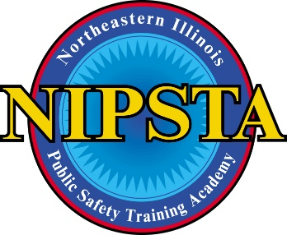
ADA ACCOMMODATIONS: AUTHORIZATION FOR RELEASE OF INFORMATION

I, __________________________________________ (Applicants full name)
Hereby authorize the person listed below to exchange information with the Northeastern Illinois Public Safety Training Academy (“NIPSTA”) on my behalf. I understand that this information will only be used to collect information to evaluate my request for accommodation and arrange for accommodations that may be approved. I acknowledge that this release will expire upon completion of the final exam administration or twelve (12) months from the date of the exam administration, whichever comes first. I further understand that I can rescind this authorization at any time by contacting the NIPSTA Executive Director in writing.

___________________________________________ Applicant Signature

___________________________________________ Date

Name and address of person authorized to communicate with NIPSTA on my behalf:
___________________________________________
___________________________________________
___________________________________________
___________________________________________

